## Sep 30, 2024 | Insync Meeting 5

Attendees:

Justin Zhang, Aditya Borkar, Gowrisankar Palanickal, Ananya Subramaniam, Sahasra Yellapragada

Notes:

* Made databases
  + Assuming calendar API doesn’t use one
* Created User data table
* Finalized Sitemap
* Finalized Color Scheme
* (In progress) Sitemap
  + 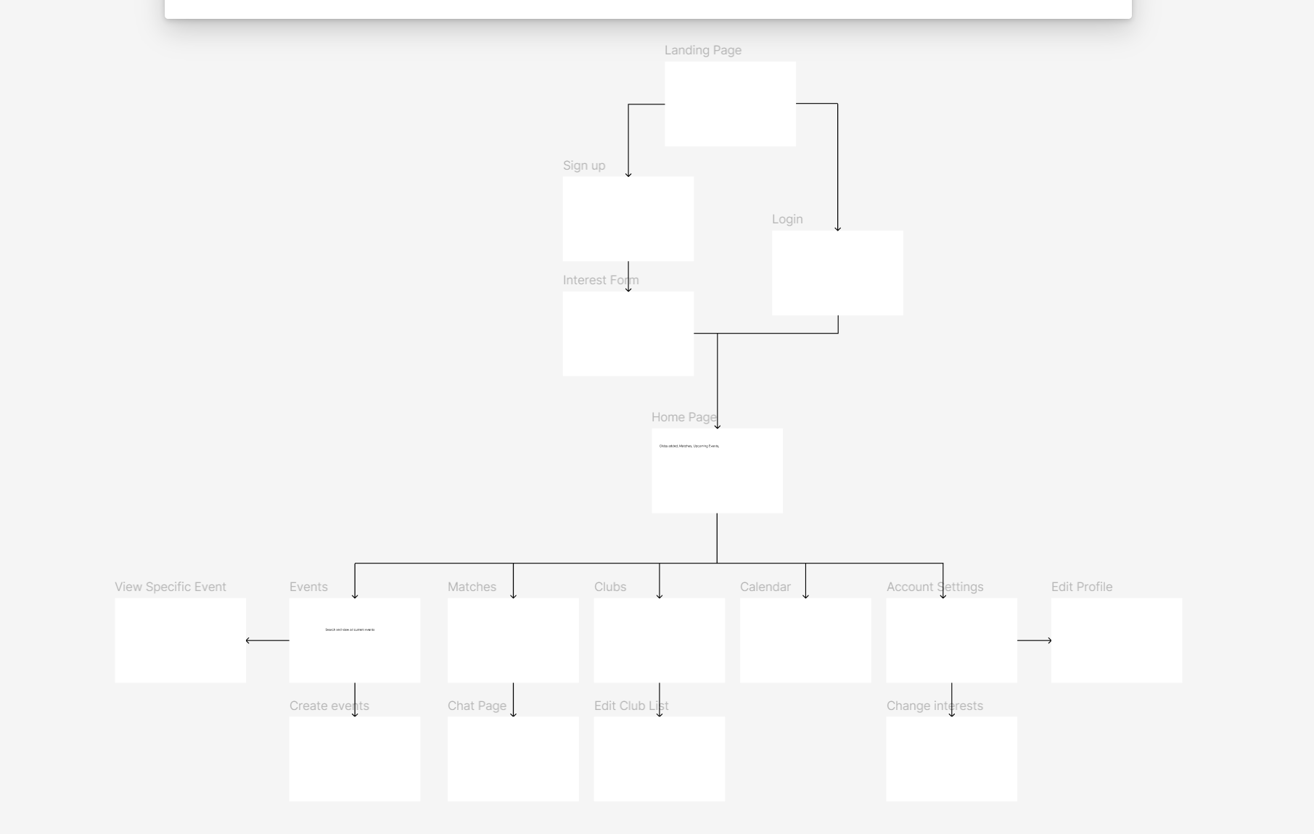

Next steps for Sprint 1

* Ananya
  + Choose chat api
* Sahasra
  + Working on wireframes
    - Paper/Figma
* Shankar
  + HTML pages - in progress
  + Choose Calendar API
* Justin
  + Add admin part to the sitemap
  + Choose chat api
* Aditya
  + Updating the databases